## Requirements

This hands-on is broken into three parts. Please complete each part within your main.py file.

Setup

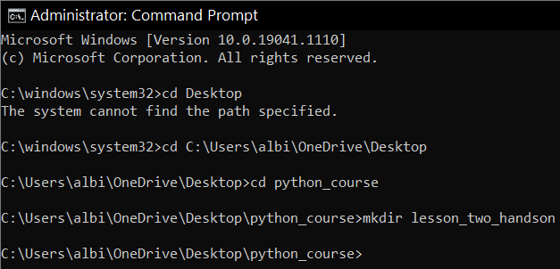

## Part 1

Create a program that will concatenate string variables together to form your birthday.

1. Create three variables named day, month and year
2. Concatenate each of these variables to create your full birthday.

Hint! You cannot concatenate strings and integers, so all variables will need to be strings

1. Assign the concatenation to a fourth variable named my_birthday.
2. Finally, print the variable my_birthday to see if you have the format identical to the one in the example below:

For example, if your birthday is on November 11th of 1991, then the format/output should be November 11, 1991

Python commands:

#Part 1

day = "1"

month = "January"

year = "1993"

my_birthday = month + " " + day + ", " + year

print(my_birthday)

Results:

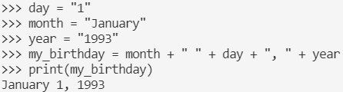

## Part 2

1. Concatenate the variables first, second, third, and fourth and set this concatenation to the variable final:

first = "happy"

second = "birthday"

third = "to"

fourth = "you"

final =

1. Print the final variable, but all words should be uppercase.
2. Run this code in the VSCode terminal.

The output should be HAPPY BIRTHDAY TO YOU.

Python commands:

#Part 2

first = "happy"

second = "birthday"

third = "to"

fourth = "you"

final = first + " " + second + " " + third + " " + fourth + " "

print(final.upper())

Results:

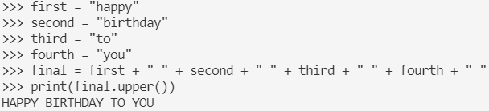

## Part 3

Finally, add code to your program that determines if the given age allows the attendee to see the movie, printing out a specific message based on the age. There should be four possible outputs:

If under the age of 10, print Not permitted

If under the age of 15, print Permitted with a parent

If under the age of 18, print Permitted with anyone over 18

If 18 or over, print Permitted to attend alone

Below is some code to get you started:

age = 15

if

Python commands:

#Part 3

age = 15

if age < 10:

print("Not Permitted")

elif age < 15:

print("Permitted with a parent")

elif age < 18:

print("Permitted with anyone over 18")

elif age >= 18:

print("Permitted to attend alone")

Results:

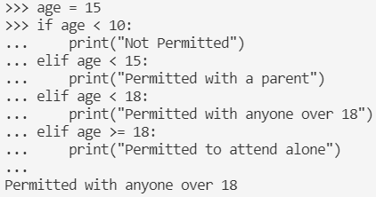

#Part 3 Alternative

age = 15

if age < 10:

print("Not Permitted")

elif age < 15:

print("Permitted with a parent")

elif age < 18:

print("Permitted with anyone over 18")

else:

print("Permitted to attend alone")

Results:

